

You are going to prepare and present a news report on a story of your choice.
- As an example, look at a current news article from BBC News below.
- For each of the sentences, rewrite the underlined clauses using the passive form

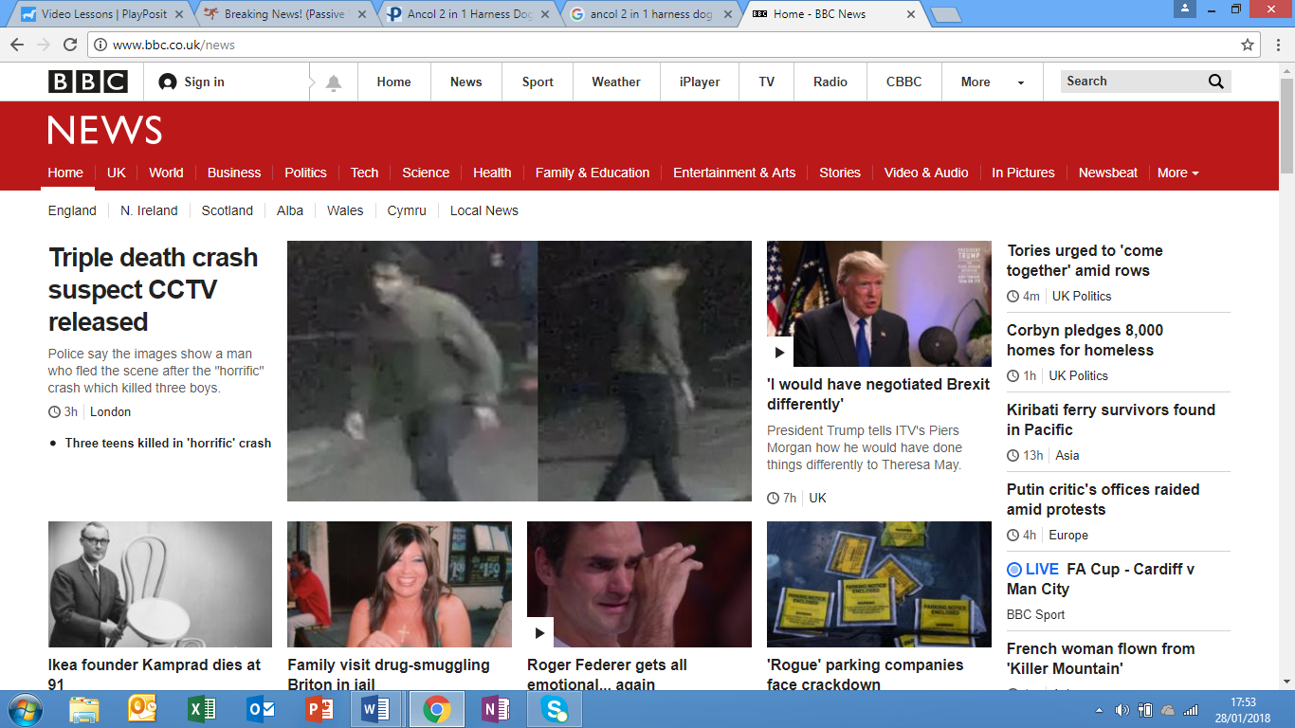

Votes at 16: Wales voting reforms see voting age lowered
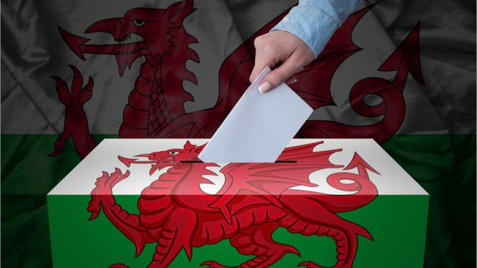
1. People aged 16 and 17 could soon be able to cast a vote in Wales under Welsh Government plans to modernise elections.
Example: Elections will be modernised by the Welsh Government

2. The Welsh Government is planning to lower the voting age to allow younger people to vote at the council elections in 2022.
__________________________________________________________________________
__________________________________________________________________________
3. If the Welsh Government passes the vote, the plans would allow young people aged 16 and 17 to vote in Wales' next local elections to be held in May 2022.
__________________________________________________________________________
__________________________________________________________________________

4. Some people have argued that if the government does not give young people the right to vote then they are denying them their rights as citizens.
__________________________________________________________________________
__________________________________________________________________________
__________________________________________________________________________

5. Scotland has already lowered the voting age for the Scottish and local government elections - with 16-year-olds also able to vote in the independence referendum in 2014.
__________________________________________________________________________

__________________________________________________________________________

6. The UK Government still controls General Elections so the changes would not apply when choosing a Prime Minister.
__________________________________________________________________________

__________________________________________________________________________

7. In addition, the plans would mean that the Welsh Government would give citizens of other countries the right to vote at local elections.
__________________________________________________________________________

__________________________________________________________________________

8. The UK government said it had no plans to lower the voting age.
__________________________________________________________________________
__________________________________________________________________________

9. Conservative Assembly Member, Janet Finch-Saunders said it was vital that someone looked very closely at the plans before any changes were made.
__________________________________________________________________________
__________________________________________________________________________

Now it’s your opportunity to research and present a news story of your choice for 1 minute.
- Research the Internet and find a news story that you find interesting.
- Make notes (in English) about the most important information including what happened and who is/was involved. Make sure that you include passive sentences.
- From your notes, write a script (about 150 words) to read when you are presenting your news report.

You can make notes here:

Write your script here:
__________________________________________________________________________
__________________________________________________________________________
__________________________________________________________________________
__________________________________________________________________________
__________________________________________________________________________
__________________________________________________________________________
__________________________________________________________________________
__________________________________________________________________________
__________________________________________________________________________
__________________________________________________________________________
__________________________________________________________________________
__________________________________________________________________________
__________________________________________________________________________
__________________________________________________________________________
__________________________________________________________________________

